**Computer Vision on Different Architectures: A Comparative Study of Raspberry Pi 4 and Raspberry Pi 5**

**Abstract**

This study compares the performance of the Raspberry Pi 4 (RISC) and Raspberry Pi 5 (CISC), both with 4GB RAM, in running computer vision algorithms, specifically face detection using OpenCV in Python. We test both devices with the same webcam, capturing faces from multiple angles, and analyze processing time, FPS, CPU clock speed, and CPU temperature. The results show that while both Pis perform well, the Raspberry Pi 5 outperforms the Pi 4 by a decent margin, particularly when detecting multiple faces at once.

**Keywords**

Raspberry Pi, Computer Vision, Object Detection, Facial Recognition, OpenCV, Python, Geekbench, Performance Comparison.

**Introduction**

Computer vision tasks are being used more often on affordable embedded systems. The Raspberry Pi is popular because it’s inexpensive and versatile. The new Raspberry Pi 5 offers better CPU and GPU performance compared to the Raspberry Pi 4. This paper compares the 4GB versions of both models for real-time object detection using OpenCV. We analyze performance metrics such as frame rate (FPS), CPU clock speed, CPU temperature, and Geekbench scores to see if the Raspberry Pi 5’s slightly newer hardware and its CISC architecture make a noticeable difference for computer vision tasks. Our goal is to determine whether the Raspberry Pi 5’s higher cost is worth it for these applications, or if the Raspberry Pi 4 is a more cost-effective choice since both models have a similar amount of RAM and offer similar hardware.

**Methodology**

We used the same webcam to capture images of each team member’s face, taking ten photos from three different angles: front, left, and right. These images were used to train and test the face detection algorithm. A Python script implementing OpenCV was developed to detect faces in real-time, drawing bounding boxes around each detected face and labeling them with the corresponding person’s name. The setup was tested on both the Raspberry Pi 4 and Raspberry Pi 5. We used Geekbench to benchmark the devices, focusing on metrics such as frames per second (FPS), CPU usage, memory consumption, and detection accuracy. Testing conditions, including lighting, camera module, and object distance, were kept consistent to minimize external variables.

**Results**

**FPS Comparison**

Both Raspberry Pi models successfully detected individual faces with similar accuracy. The Raspberry Pi 5 exhibited a higher FPS during face detection, with more responsive performance, especially when multiple faces were present in the frame. Both systems experienced a noticeable drop in FPS when all team members were in view, but neither device required thermal throttling. Geekbench benchmarking results (*Table 1*) confirmed that the Raspberry Pi 5 outperformed the Raspberry Pi 4 in both single-core and multi-core performance, with single-core scores of 884 and 294, respectively, and multi-core scores of 2090 and 681, respectively.

Table Ⅰ. Key Geekbench Results for Raspberry Pi 4 and Raspberry Pi 5

| Device | Single-Core Score | Multi-Core Score | Object Detection (Single-Core) | Object Detection (Multi-Core) |
| --- | --- | --- | --- | --- |
| Pi 4 | 294 | 861 | 2.77 images/sec | 7.99 images/sec |
| Pi 5 | 884 | 2090 | 20.6 images/sec | 34.3 images/sec |

*Figure 1* shows the FPS performance of the Raspberry Pi 5 over time. The maximum frame rate observed was **7.76 FPS** when no faces were in the frame. When one face appeared (around frames 45 to 63), the frame rate dropped to approximately **7.0 FPS**. As a second person entered the frame (frames 63 to 90), the FPS decreased further to around **6.0**. With a third person (frames 90 to 120), it dropped to **4 FPS**. Finally, when all four team members were in view (after frame 120), the FPS fell to its lowest range, around 2–3 FPS. A similar trend is observed with the Raspberry Pi 4, as shown in *Figure 2*. However, the Pi 4 consistently performed worse than the Pi 5, with a maximum FPS of 6.07 and a minimum of just 0.47.

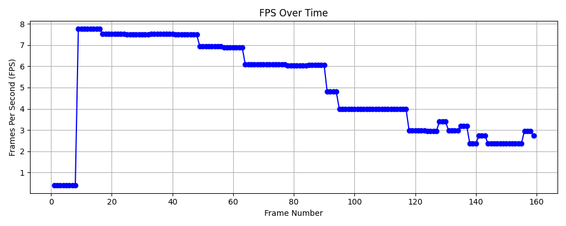

Fig. 1. FPS performance of the Raspberry Pi 5 during face detection over time. As more faces appear in the frame, the frame rate decreases, demonstrating the effect of increased computational load.

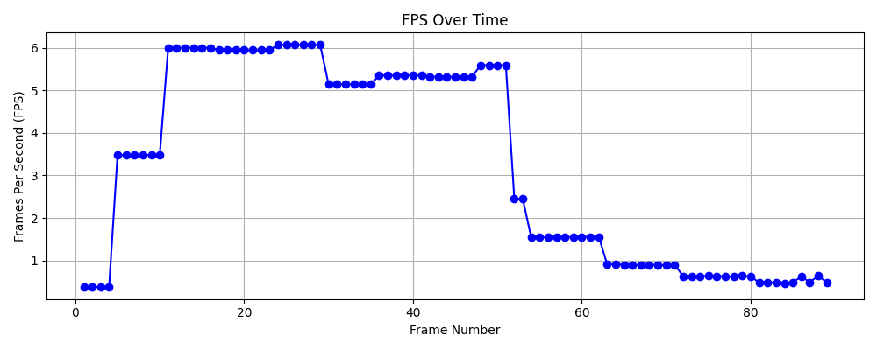

Fig. 2.FPS performance of the Raspberry Pi 4 during face detection over time. The device shows a similar trend to the Pi 5 but with overall lower performance, especially under heavier workloads.

**CPU Temperature Comparison**

*Figures 3 and 4* show the CPU temperature of the Raspberry Pi 4 and Raspberry Pi 5, respectively, during various stages of the experiment, including image capturing, model training, and face detection.

For the Raspberry Pi 5, the CPU temperature started around 37°C and gradually increased to about 46°C during facial recognition. The temperature remained relatively stable and did not show signs of thermal throttling throughout the tasks.

For the Raspberry Pi 4, the CPU temperature began at around 46°C and peaked near 53°C, indicating a higher overall temperature range compared to the Pi 5 under the same workload. However, like the Pi 5, the Pi 4 did not reach critical temperatures that would trigger throttling.

This suggests that the Raspberry Pi 5 not only performs better in terms of FPS and processing speed but also runs cooler during extended computer vision tasks. The improved thermal management and upgraded hardware in the Pi 5 contribute to its advantage in both performance and stability.

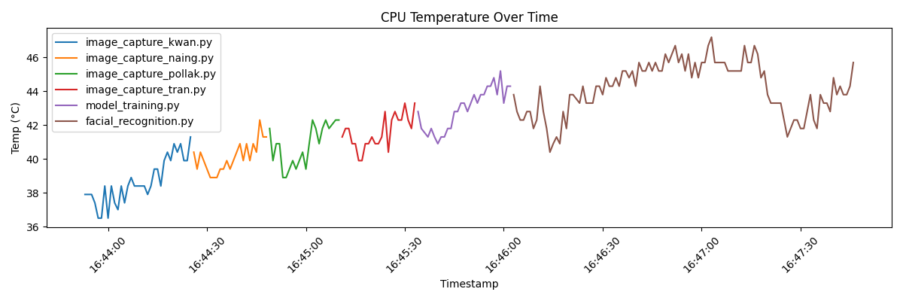

Fig. 3.CPU temperature of the Raspberry Pi 4 during image capturing, model training, and facial recognition.

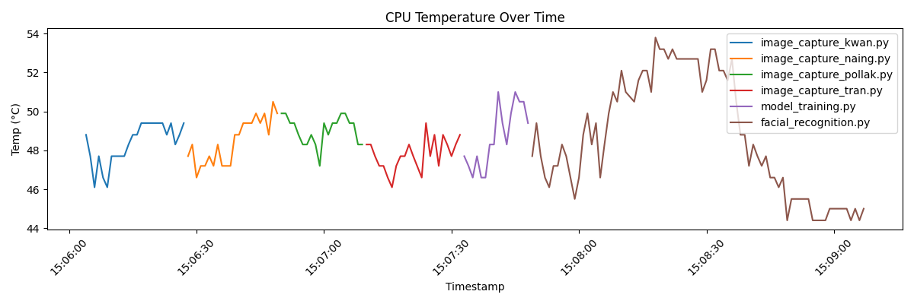

Fig. 4.CPU temperature of the Raspberry Pi 5 during image capturing, model training, and facial recognition.

**Discussion**

The results show that both the Raspberry Pi 4 and Raspberry Pi 5 handle face detection well, but the Raspberry Pi 5 performs better overall. The Pi 5 has higher frame rates (FPS) and greater processing power, especially when detecting more faces. Both devices experienced a drop in FPS when multiple faces were in the frame, but the Pi 5 still performed better.

While the Pi 4’s temperature increased more than the Pi 5’s, neither device needed to throttle, meaning both could run the task without overheating or slowing down too much. The Pi 5's improved CPU and GPU contribute to its better performance, but both devices performed similarly when detecting fewer faces. These results suggest that for tasks involving multiple objects or more complex applications, the Pi 5 is the better choice.

**Conclusion**

In conclusion, while both the Raspberry Pi 4 and Raspberry Pi 5 are capable of running computer vision tasks like face detection, the Raspberry Pi 5 offers better performance, especially for more demanding tasks. The improved hardware of the Pi 5 leads to faster frame rates and better efficiency when detecting multiple faces. If the goal is to run more complex or real-time computer vision tasks, the Raspberry Pi 5 is a more suitable choice. However, if the tasks are simpler or budget is a concern, the Raspberry Pi 4 still offers good performance at a lower cost.

**References**

[1] Geekbench, "Geekbench Results for Raspberry Pi 4," [Online]. Available: https://browser.geekbench.com/v6/cpu/11225851. [Accessed: Apr. 2025].

[2] Geekbench, "Geekbench Results for Raspberry Pi 5," [Online]. Available: https://browser.geekbench.com/v6/cpu/11059325. [Accessed: Apr. 2025].